2020-2021 AP Human Geography Summer Assignment

What am I doing? Labeling world outline maps with the features listed below building an understanding of the political and physical geography world regions.

Why am I doing this? Part of entering an AP class is an assumption of a certain level of background knowledge and skills. You will need a strong working mental map in order to be successful in this course.

When are the maps due? A physical copy of the maps is due The First Day of School!

How many maps should I submit? 14
Map 1 – Map Basics | Map 8 – Sub-Saharan Africa
Map 2 – Land Features | Map 9 – North Africa & the Middle East
Map 3 – Rivers and Lakes | Map 10 – E Asia, C Asia, S Asia, and SE Asia
Map 4 – Seas, Gulfs, and other Major Water Features | Map 11 – Central and South Asia
Map 5 – North America and the Caribbean | Map 12 – Oceania
Map 6 – South America | Maps 13 – World Regions A Big Picture
Map 7 – Europe | Maps 14 –World Regions A Closer Look

What do I label on each map? Each map has a list of countries, cities and/or regions to label. The list and corresponding numbers will serve as the key. Label each element with the correct number in the correct location. Only items labeled on the correct maps will be scored and tested. Countries are listed in regular font and cities are listed in italics. NOTE: Bolded items have emphasis in APHG.

When is the first map test? There will be one test in the first six weeks and more through the year. It is essential that you build a mental map of the world and the placement of states (countries), cities and natural phenomena.

How do I study? Studying for map tests takes time and preparation. The first step is to find each feature and label blank outline maps. Use the list below and quiz yourself by labeling blank maps and seeing how much you know. Listed below are links where you can test yourself online.

Coloring the maps is required. This will help with memorization. In order to explain what the color represents, draw a square next to the item that is being labeled. I have provided an example below.
Ex. Iceland -

If you have any questions or concerns, please reach out to me via email at drummf@manateeschools.net

Use these maps as a reference for labeling and coloring maps 13 and 14.
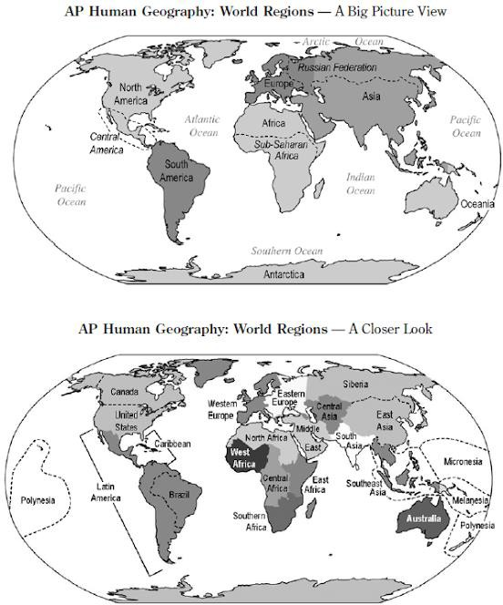

Map 1: Basics

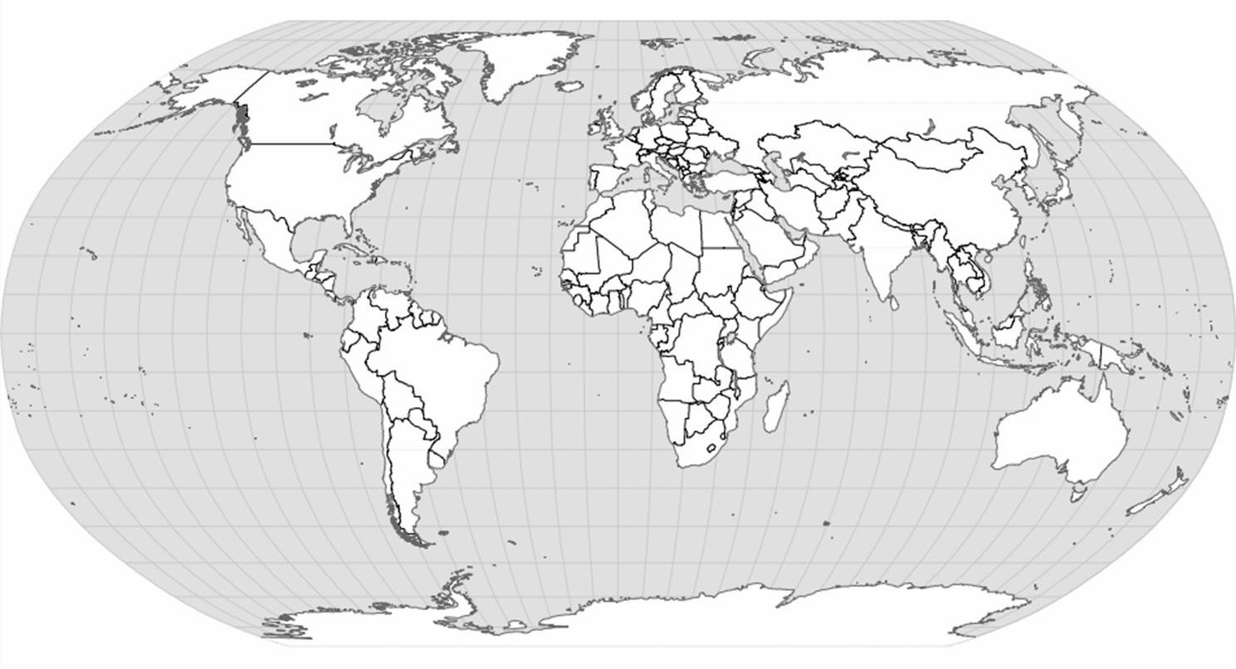

Label the following:  5 Oceans Arctic Circle | 7 Continents Antarctic Circle | Tropic of Cancer Prime Meridian | Equator  International Date Line | Tropic of Capricorn Southern Ocean
After labeling Map 1, complete the following sentences:
Lines of latitude run from to and measure distances and of the .

Lines of longitude run from to and measure distances and of the

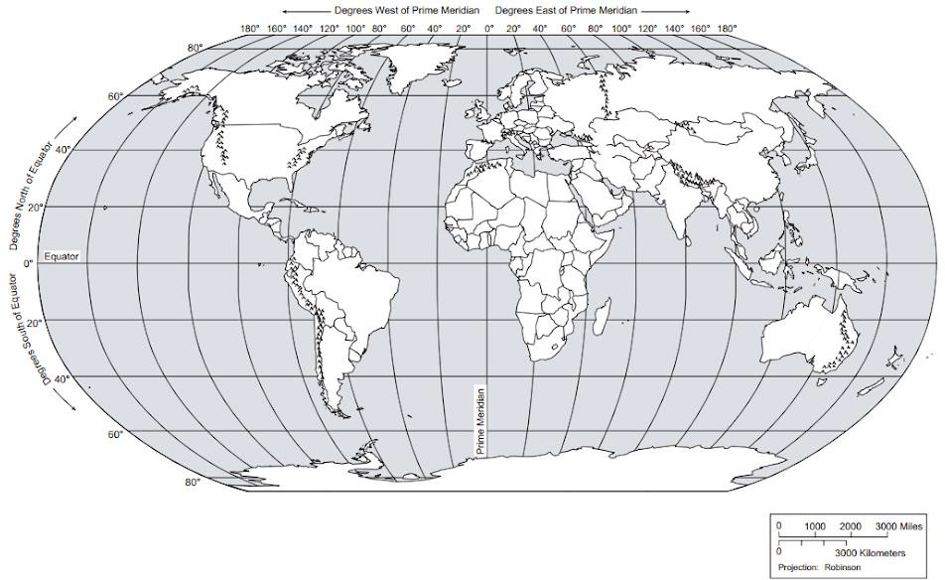

Map 2: Land Features

Label the following:  1. Rockies | 4. Appalachians | 7. Sahara | 10. Urals | 13. Kalahari
2. Himalayas | 5. Caucasus | 8. Alps | 11. Rub al Khali | 14. Namib
3. Gobi | 6. Andes | 9 Atacama | 12. Patagonia

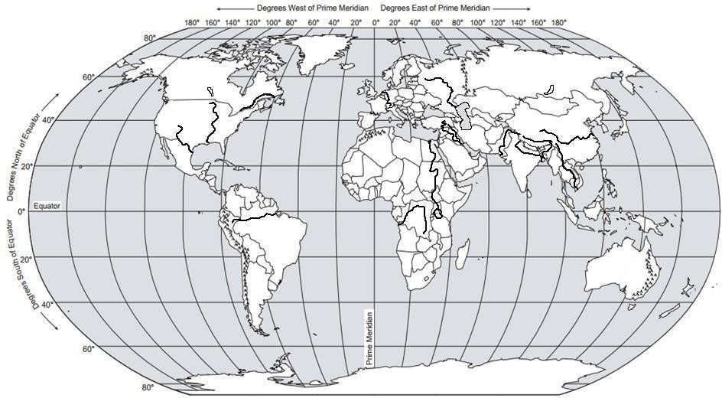
Map 3: Rivers and Lakes

Label the following:  1. Brahmaputra River | 6. Mississippi River | 11. Ganges River | 16. Lake Superior | 21. Rio Grande River
2. Tigris River | 7. Indus River | 12. Congo River | 17. Lake Michigan | 22. Lake Baikal
3. Euphrates River | 8. Mekong River | 13. Volga River | 18. Lake Erie | 23. St. Lawrence River
4. Yangtze River | 9. Amazon River | 14. Lake Winnipeg | 19. Lake Ontario
5. Nile River | 10. Lake Victoria | 15. Rhine River | 20. Lake Huron

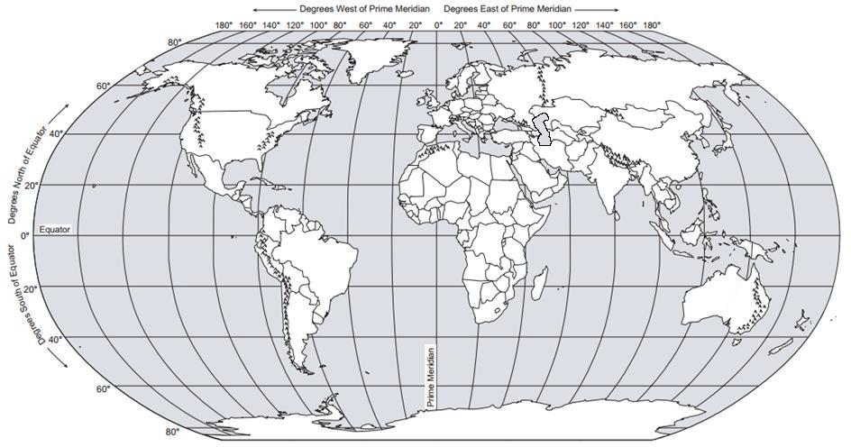
Map 4: Seas, Gulfs, and other Major Water Features

Label the following:
1. Caspian Sea | 5. South China Sea | 9. Gulf of Aden | 13. Strait of Malacca | 17. English Channel
2. Mediterranean Sea | 6. Caribbean Sea | 10. Strait of Hormuz | 14. Mandeb Strait
3. Red Sea | 7. Gulf of Mexico | 11. Dardanelles Strait | 15. Strait of Gibraltar
4. Aral Sea | 8. Persian Gulf | 12. Bosporus Strait | 16. Panama Canal

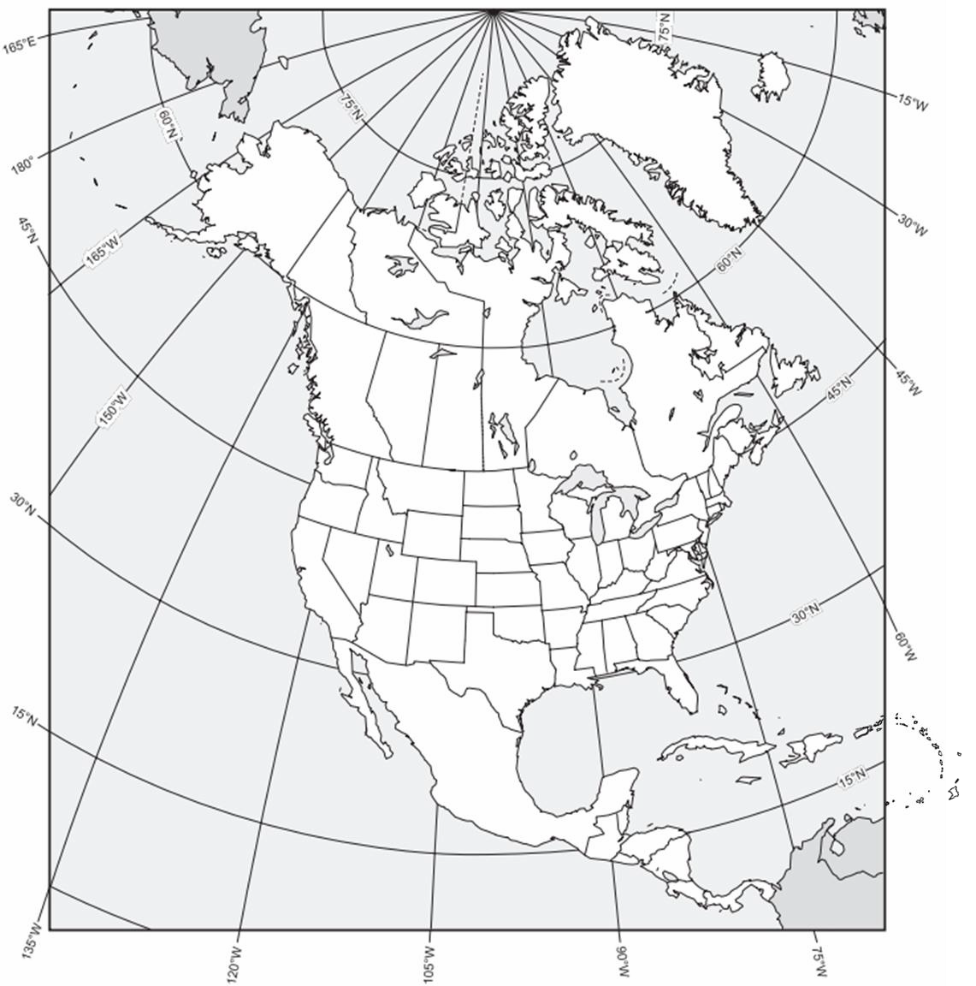
Map 5: North America and the Caribbean

Label the following:  1. Bahamas | 6. Cuba | 11. Dominican Republic | 16. Haiti | 21. Jamaica
2. Trinidad and Tobago | 7. Belize | 12. Costa Rica | 17. El Salvador | 22. Guatemala
3. Honduras | 8. Mexico | 13. Nicaragua | 18. Panama | 23. Canada
4. United States | 9. Greenland | 14. Chicago | 19. Havana | 24. Los Angeles
5. Managua | 10. Mexico City | 15. New York City | 20. Ottawa | 25. Washington DC

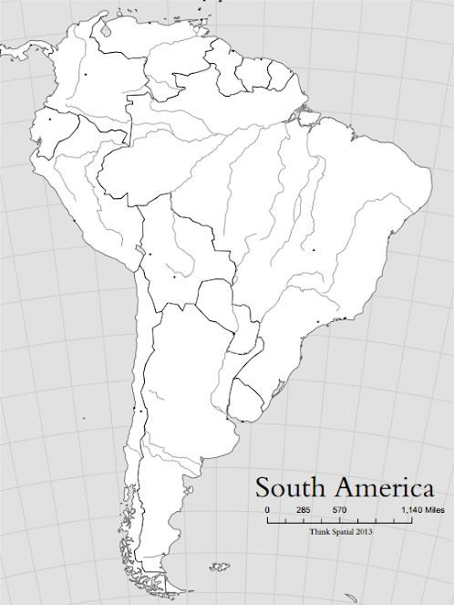
Map 6: South America

Label the following  1. Argentina | :  6. Colombia | 11. Uruguay | 16. French Guiana | 21. Lima
2. Ecuador | 7. Paraguay | 12. Chile | 17. Buenos Aires | 22. Brasília
3. Peru | 8. Venezuela | 13. São Paulo | 18. Bolivia
4. Caracas | 9. Rio de Janeiro | 14. Suriname | 19. Falkland Islands
5. Santiago | 10. Guyana | 15. Brazil | 20. Bogotá

Map 7: Europe  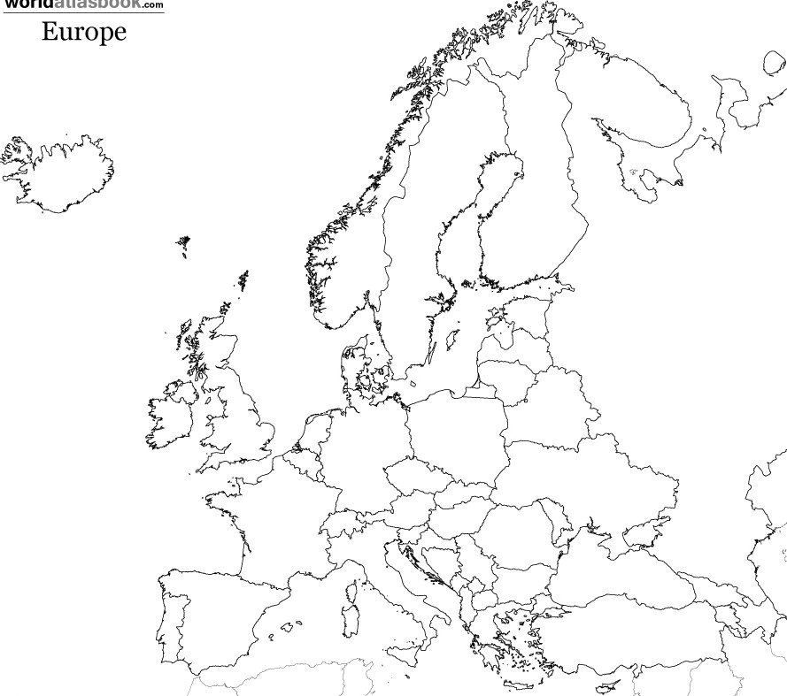 |  |  |  | Label the following:  - The Hague  - Rome  - Moscow  - London  - St. Petersburg  - Brussels  - Paris  - Madrid  - Berlin  - Switzerland  - Netherlands  - Monaco  - Luxembourg  - Liechtenstein  - Germany  - France  - Belgium  - Austria  - Spain  - Slovenia  - Serbia  - San Marino  - Portugal  - Montenegro  - Malta  - Macedonia  - Italy  - Holy See (Vatican City)  - Greece  - Croatia  - Bosnia and Herzegovina  - Andorra  - Albania  - Belarus  - Poland
36. Denmark | 41. Lithuania | 46. Hungary | 51. Ukraine
37. Latvia | 42. Czech Republic | 47. Slovakia | 52. Ireland
38. Bulgaria | 43. Russia | 48. Iceland | 53. United Kingdom
39. Romania | 44. Finland | 49. Sweden | 54. Kosovo
40. Estonia | 45. Norway | 50. Moldova

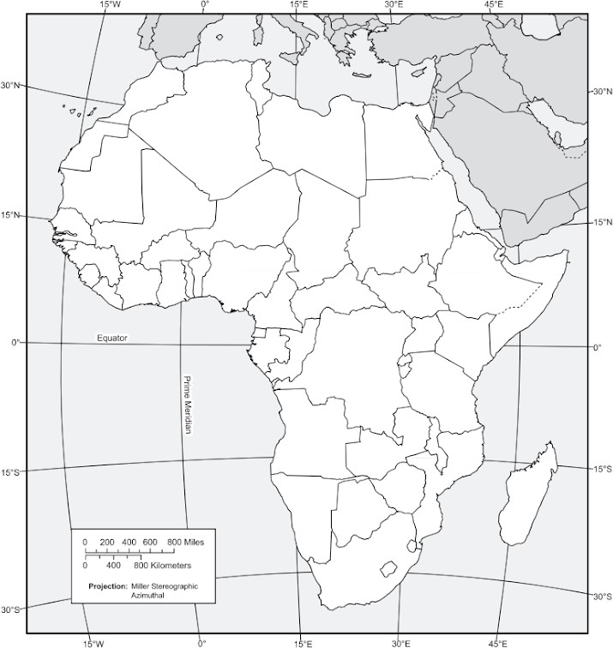
Map 8: Sub-Saharan Africa

Label the following  1. Burundi | :  12. Djibouti | 23. Eritrea | 34. Ethiopia | 45. Niger
2. Madagascar | 13. Botswana | 24. Chad | 35. Rwanda
3. Somalia | 14. South Sudan | 25. Uganda | 36. Tanzania
4. Zimbabwe | 15. Angola | 26. Cameroon | 37. Central African
5. Congo | 16. Togo | 27. Zambia | 38. Ghana
6. Lesotho | 17. Namibia | 28. South Africa | 39. Swaziland
7. Burkina Faso | 18. Cape Verde | 29. Côte d’Ivoire | 40. Gambia
8. Benin | 19. Liberia | 30. Mali | 41. Mauritania
9. Nigeria | 20. Senegal | 31. Sierra Leone | 42. Democratic
10. Addis Ababa | 21. Cape Town | 32. Lagos | 43. Nairobi
11.Mogadishu | 22. Johannesburg | 33. Accra | 44. Kenya

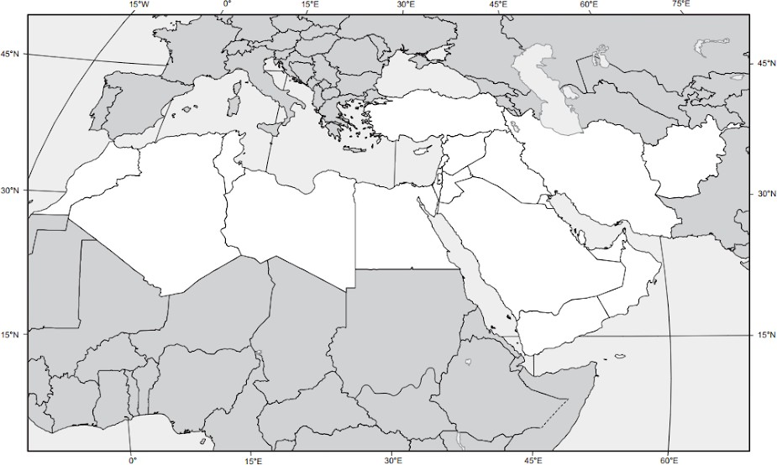
Map 9: North Africa and the Middle East

Label the following:  1. Algeria | 8. Egypt | 15. Libya | 22. Morocco | 29. Sudan
2. Tunisia | 9. Armenia | 16. Azerbaijan | 23. Jerusalem | 30. Cyprus
3. Georgia | 10. Iraq | 17. Israel | 24. Jordan | 31. Kuwait
4. Lebanon | 11. Oman | 18. Palestine | 25. Qatar | 32. Saudi Arabia
5. Syria | 12. Turkey | 19. United Arab Emirates | 26. Yemen | 33. Baghdad
6. Beirut | 13. Cairo | 20. Damascus | 27. Istanbul | 34. Iran
7. Tehran | 14. Tripoli | 21. Mecca | 28. Medina | 35. Afghanistan

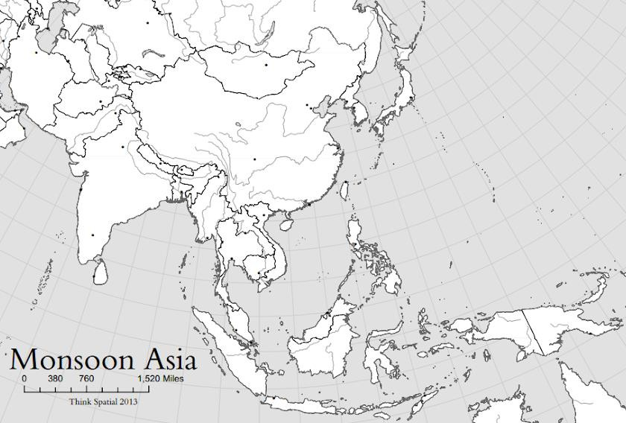
Map 10: East and Southeast Asia

Label the following:

1. Tokyo | 6. Jakarta | 11. Vietnam | 16. Philippines | 21. North Korea
2. Shanghai | 7. Japan | 12. Hong Kong | 17. Myanmar (Burma) | 22. Cambodia
3. Seoul | 8. Beijing | 13. Thailand | 18. China | 23. Brunei
4. Pyongyang | 9. Bangkok | 14. Singapore | 19. Laos | 24. Mongolia
5. Taiwan | 10. Timor-Leste | 15. Malaysia | 20. South Korea | 25. Indonesia

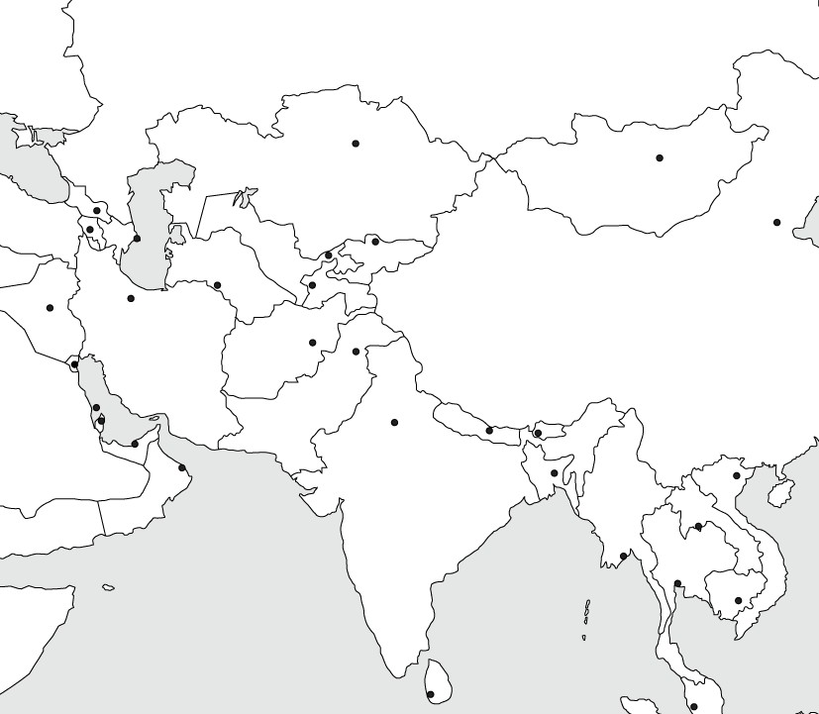
Map 11: Central and South Asia

Label the following:  1. Sri Lanka | 4. Pakistan | 7. Nepal | 10. Maldives | 13. India
2. Bhutan | 5. Bangladesh | 8. Kashmir | 11. Kazakhstan | 14. Uzbekistan
3. Kyrgyzstan | 6. Tajikistan | 9. Turkmenistan | 12. Calcutta | 15. New Delhi

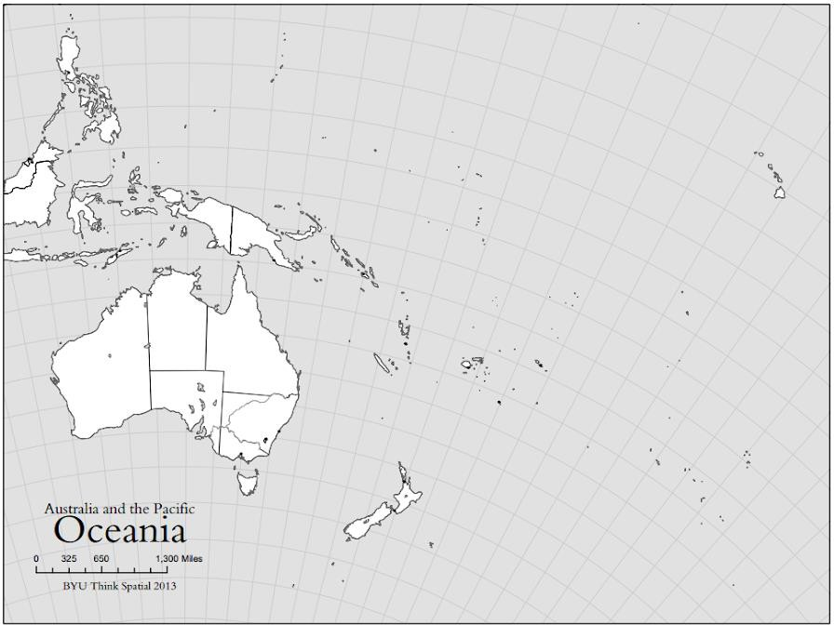
Map 12: Oceania

n
Label the following an  1. Sydney | d draw a circle around Micro  3. Auckland | esia, Melanesia, and Polynesia.  5. New Zealand | 7. Polynesia | 9. Papua New Guinea
2. Melbourne | 4. Australia | 6. Micronesia | 8. Melanesia

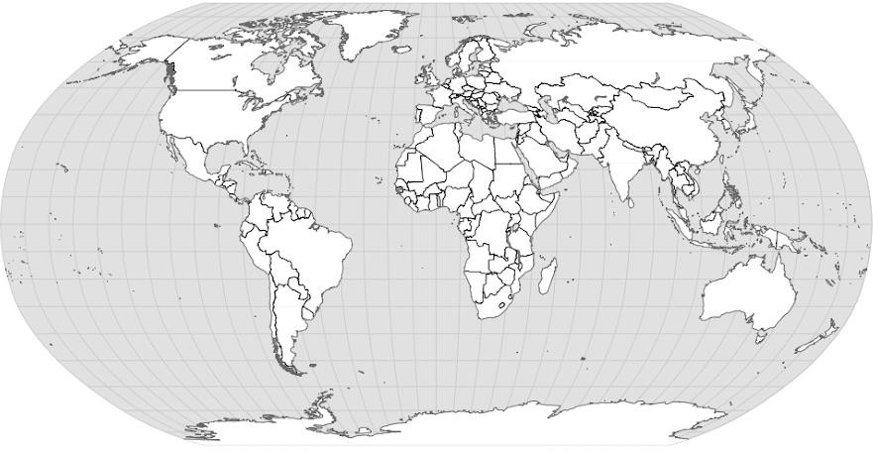
Map 13: World Regions (Big Picture)

This map will be colored based on region not state (country). Each REGION must be a single color. Draw a circle around Central America, Sub- Saharan Africa, and the Russian Federation. Use the sample map provided to help you.
1. North America | 3. Africa | 5. Central America | 7. Sub-Saharan Africa | 9. South America
2. Asia | 4. Europe | 6. Oceania | 8. Russian Federation | 10. Antarctica

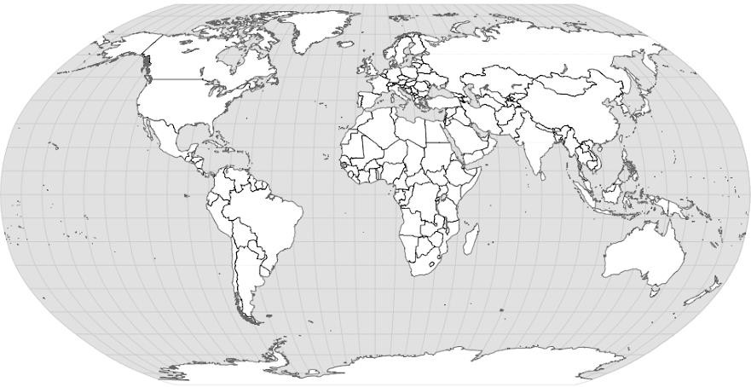
Map 14: World Regions (Closer Look)

This map will be colored based on region not state (country). Each REGION must be a single color. Draw a circle around Eastern Europe, East Asia, SE Asia, and S Asia. Bracket the Caribbean and Latin America. Use the sample map provided to help you.
1. Latin America | 4. Western Europe | 7. Eastern Europe | 10. North Africa and Middle East | 13. West Africa
2. Central Africa | 5. East Africa | 8. Southern Africa | 11. Siberia | 14. Central Asia
3. South Asia | 6. East Asia | 9. Southeast Asia | 12. Australia | 15. Antarctica

